Intermediate Algebra Lecture 11.3: Solving Equations Using Various Quadratic Methods

Applications
Steps:
- If 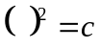 Then take the square root 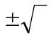 to both sides of equation
- If not above then make 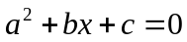
- Try factoring above if obvious
- If you cannot factor easily then use quadratic formula
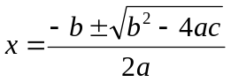

Example
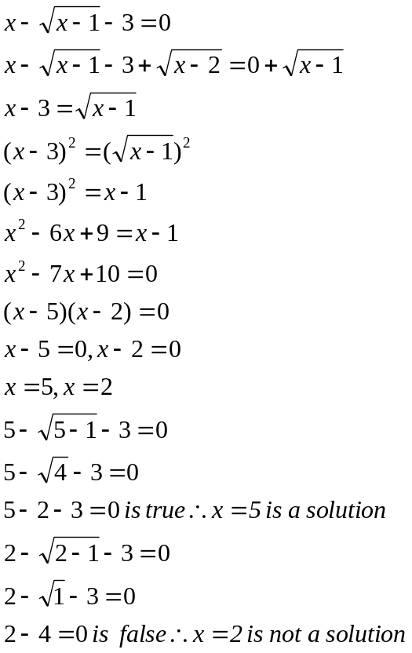

Example
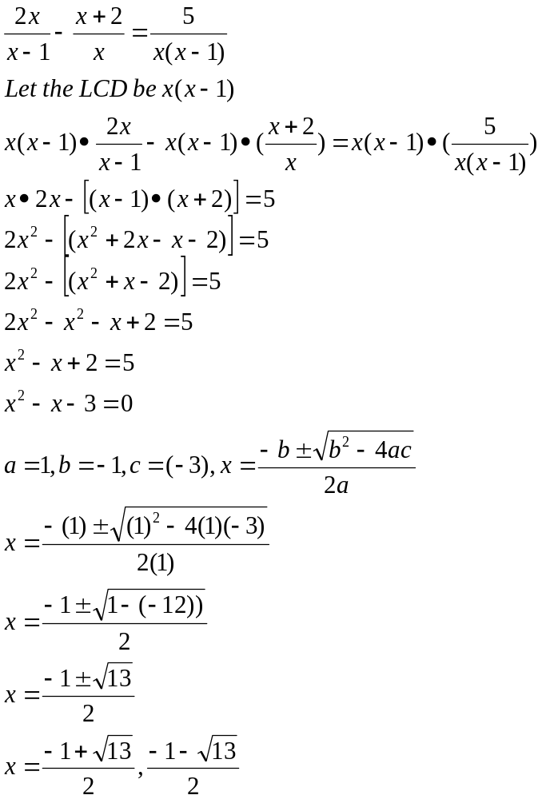

Example
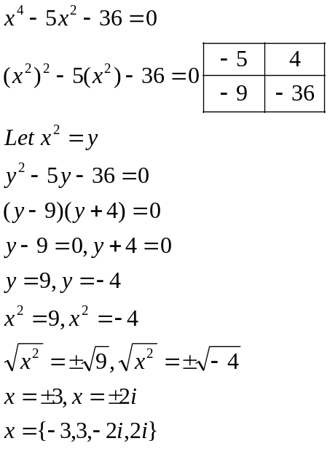

Example
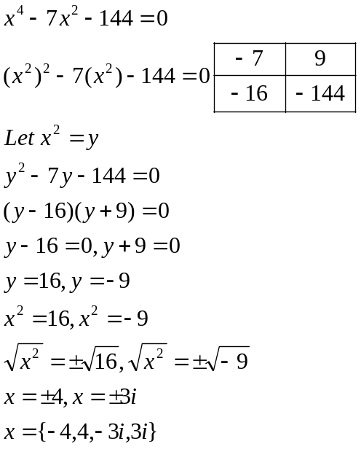

Example
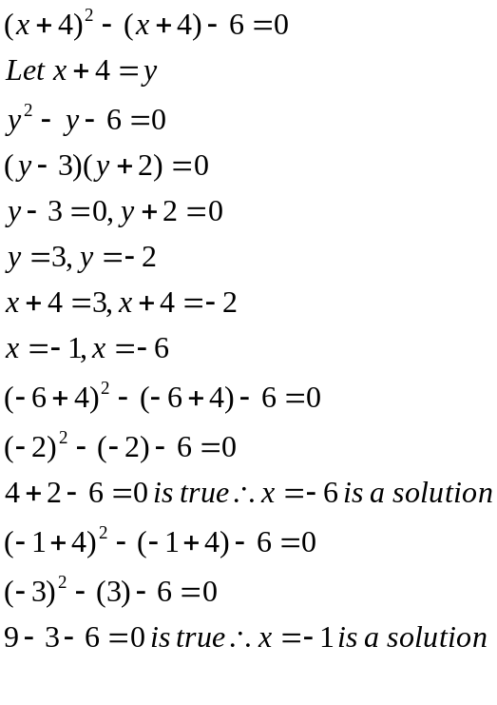
Example
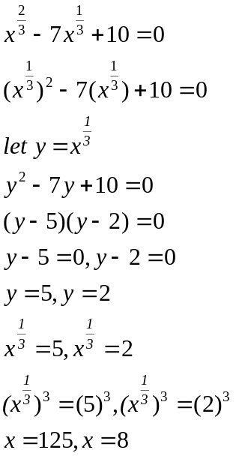

Example
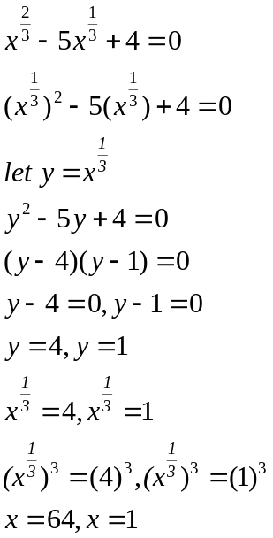

Example
Work time Karen and Doug can clean a house together in 5 hours.
Alone Karen can clean it in 1 hour faster than Doug. How fast
can each person clean the house alone?

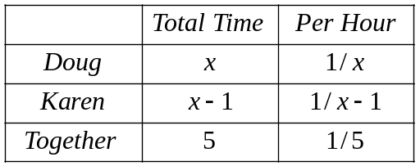

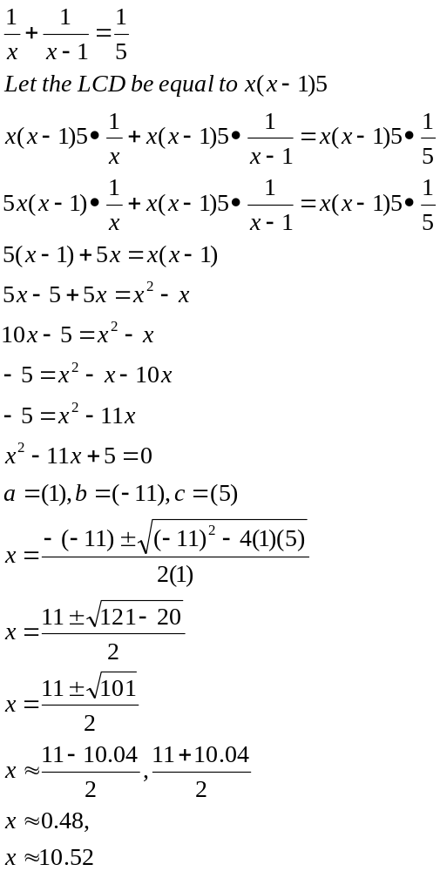

Doug can clean the house in 10.5 hours approximately
While Karen can clean the house in 9.5 hours approximately

